**Name : Patel Nidhi**

Assignment :

1. **Module -1: Understanding of Hardware and Its Components**

***Section 1: Multiple Choice***

1. **Which of the following is NOT a component of the CPU?**

Ans : 2. RAM

1. **What is the function of RAM in a computer?**

**Ans :** RAM (Random Access Memory) temporarily stores data and instructions that the CPU is currently using, allowing for fast access and smooth multitasking. It is volatile memory

1. **Which of the following is a primary storage device?**

**Ans:** None of the given options. Actually, Primary storage

= RAM & ROM, not HDD/SSD/SD card.

**4. What is the purpose of a GPU?**

A GPU (Graphics Processing Unit) purpose is:

* Render images, videos, and animations.
* Perform parallel processing for tasks like gaming, 3D modeling, video editing.
* Accelerate AI, machine learning, and scientific computations.

***Section 2: True or False***

**5. True or False: The motherboard is the main circuit board of a computer where other components are attached.**

**Ans :** True

**6. True or False: A UPS (Uninterruptible Power Supply) is a hardware device that provides emergency power to a load when the input power source fails.**

**Ans :** True

**7. True or False: An expansion card is a circuit board that the**

**functionality of a component.**

**Ans :** True

***Section 3: Short Answer***

**8. Explain the difference between HDD and SSD.**

**ANS : *HDD SSD***

| Feature | HDD (Hard Disk Drive) | SSD (Solid State Drive) |
| --- | --- | --- |
| Technology | Uses spinning magnetic disks (platters) to read/write data with a mechanical arm. | Uses flash memory (chips) with no moving parts. |
| Speed | Slower Boot time and file transfer take longer. | Much faster |
| Durability | More fragile (moving parts can break if dropped). | More durable (no moving parts). |
| Storage Capacity | Generally cheaper, available in larger sizes (up to several TB). | More expensive, usually smaller capacity (though high-capacity SSDs exist). |
| Noise | Produces noise due to spinning disks. | Completely silent. |
| Power Consumption | Uses more power. | More energy-efficient. |

**9. Describe the function of BIOS in a computer system**

**Ans :**

* **Performs POST (Power-On Self-Test):**
* Checks if CPU, RAM, storage, and other hardware are working properly when the computer is powered on.
* **Provides Basic Input/Output Services:**
* Allows communication between the operating system and hardware at a low level.

**10. List and briefly explain three input devices commonly used with computers**

**Ans :**

* **Keyboard**
* Used to input text, numbers, and commands into a computer.
* Includes keys for letters, numbers, symbols, and special functions.
* **Mouse**
* A pointing device that controls the movement of a pointer on the screen.
* Used for selecting, dragging, clicking, and interacting with graphical elements.
* **Scanner**
* Converts physical documents or images into digital format.

***Section 4: Practical Application***

**11. Identify and label the following components on a diagram of a motherboard: ● CPU ● RAM slots ● SATA connectors ● PCI-E slot**

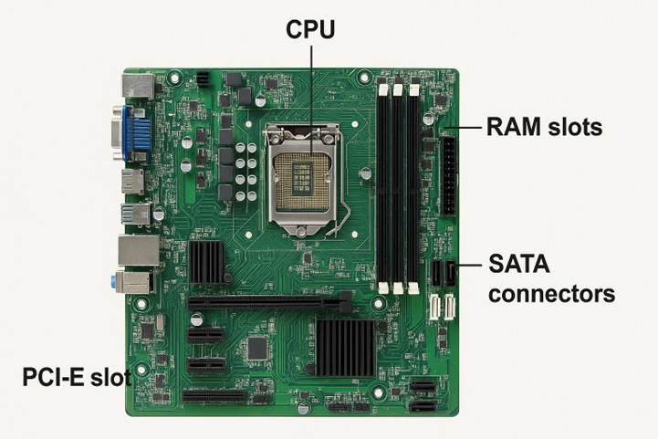

**12. Demonstrate how to install a RAM module into a computer.**

**Ans :**

1. Power Off and Unplug the computer completely.
2. Open the Case carefully using a screwdriver if needed.
3. Locate the RAM Slots (next to the CPU socket).
4. Unlock the Clips at both ends of an empty RAM slot.
5. Align the RAM Module with the slot – note the notch in the connector to ensure it fits only one way.
6. Insert the RAM firmly into the slot, pressing down evenly until the clips snap into place.
7. Close the Case and reconnect the power.
8. Boot the System and check the BIOS or operating system to confirm the RAM is recognized.

***Section 5: Essay***

**13. Discuss the importance of proper cooling mechanisms in a computer system. Include examples of cooling methods and their effectiveness.**

**Ans :**

Here the Importance of Proper Cooling Mechanisms in a Computer System

* Proper cooling in a computer system is essential to maintain performance, stability, and hardware lifespan. Modern components like the CPU, GPU, and power supply generate significant heat during operation. If heat is not managed effectively, it can cause thermal throttling (slowed performance), unexpected system crashes, or even permanent hardware damage.
* **Examples of Cooling Methods and Their Effectiveness**

1. **Air Cooling**
   * Method: Uses fans and heatsinks to draw heat away from components.
   * Effectiveness: Cost-effective, simple, and reliable for everyday computers. Suitable for normal workloads and mid-level gaming PCs.
2. **Liquid Cooling (Water Cooling)**
   * Method: Circulates coolant through tubes, absorbing heat from the CPU/GPU and dissipating it via a radiator.
   * Effectiveness: More efficient than air cooling, quieter, and ideal for high-performance gaming or workstation systems. Requires higher cost and maintenance.
3. **Thermal Paste**
   * Method: Applied between the CPU/GPU and heatsink to fill microscopic gaps, ensuring better heat transfer.
   * Effectiveness: Inexpensive but critical for maximizing cooling efficiency**.**
4. **Extreme Cooling (e.g., Liquid Nitrogen, Phase-Change Cooling)**
   * Method: Uses specialized cooling for experimental or overclocking scenarios.
   * Effectiveness: Extremely powerful but impractical for daily use due to cost and complexity.

**14. Explain the concept of bus width and its significance in computer architecture.**

In computer architecture, a bus is a communication system that transfers data between different components of the computer, such as the CPU, memory, and input/output devices**.**

* Bus width refers to the number of bits that can be transmitted simultaneously in one operation over the bus**.**
* **Significance of Bus Width**

1. **Data Transfer Capacity (Speed)**
   * Wider bus = more bits moved per clock cycle.
   * Example: A 64-bit data bus moves double the data of a 32-bit bus in one cycle, improving performance**.**
2. **Memory Addressing (Capacity)**
   * The width of the address bus determines how many memory locations the CPU can access.
   * Formula: Maximum Addressable Memory = 2address bus width2^{\text{address bus width}}2address bus width.
     + 32-bit address bus → 2322^{32}232 = 4 GB max memory.
     + 64-bit address bus → 2642^{64}264 (theoretical) = 16 exabytes**.**
3. **System Performance**
   * A wider bus reduces the number of cycles needed to transfer large amounts of data.
   * Helps in handling modern applications like video processing, gaming, and large datasets**.**
4. **Compatibility and Architecture**
   * Defines whether the system is 32-bit or 64-bit (affecting OS, applications, and drivers).